Kubernetes-Ingress
In Kubernetes, Ingress is an API object that manages external access to services within a cluster, typically HTTP and HTTPS traffic, by providing a collection of routing rules.
It acts as a smart "gatekeeper" or Layer 7 (application layer) load balancer, a single point of entry that routes incoming traffic to the correct internal services and Pods based on rules defined by the user.
Core Components
Ingress functionality relies on two main components:
- Ingress Resources.
- Ingress Controller.
- Ingress Resource (or Object): A Kubernetes resource where you define the rules for routing traffic. These rules specify details like hostnames (e.g., app.example.com), URL paths (e.g., /api), and the backend services and ports they should direct traffic to.
- Ingress Controller: The actual software component that runs within the cluster (usually as a pod) and implements the rules defined in the Ingress resources. It acts as a reverse proxy and load balancer, continuously monitoring the Kubernetes API for changes in Ingress rules and dynamically updating its configuration to enforce them. Popular Ingress controllers include NGINX, HAProxy, Traefik, and cloud-provider-specific options like the AWS ALB Controller or Google Cloud Load Balancer.
Metal LB
#kubectl apply -f https://raw.githubusercontent.com/metallb/metallb/v0.14.8/config/manifests/metallb-native.yaml
# vi ippool.yaml
apiVersion: metallb.io/v1beta1
kind: IPAddressPool
metadata:
name: first-pool
namespace: metallb-system
spec:
addresses:
- 192.168.44.240-192.168.44.250 >>>>>>>>IP range need to change
#kubectl create -f ippool.yaml
#vi l2ad.yaml
apiVersion: metallb.io/v1beta1
kind: L2Advertisement
metadata:
name: example
namespace: metallb-system
#kubectl create -f l2ad.yaml

Deploy Nginx ingress controller:
----------------------------------------
#kubectl apply -f https://raw.githubusercontent.com/kubernetes/ingress-nginx/controller-v1.13.4/deploy/static/provider/baremetal/deploy.yaml

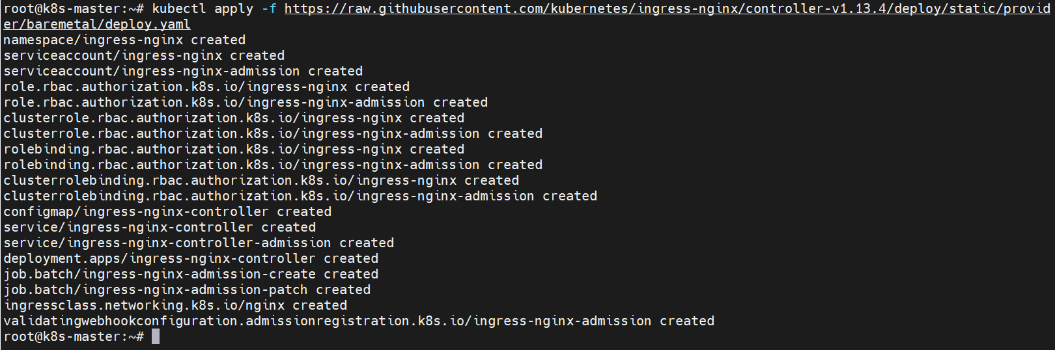

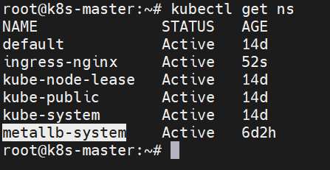

Create Deployments:
-------------------------
# kubectl create deployment httpd-deploy --image=httpd --replicas=2

# kubectl create deployment nginx-deploy --image=nginx --replicas=2

# kubectl create deployment phpmyadmin-deploy --image=phpmyadmin --replicas=2

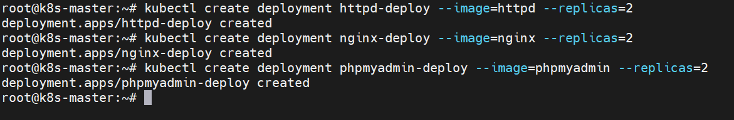

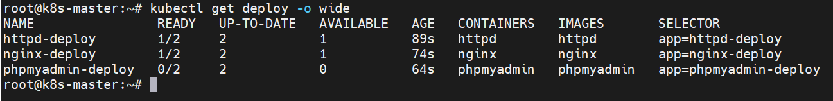

Expose Deployment:
-------------------------
# kubectl expose deployment httpd-deploy --name httpd-deploy-svc --type=NodePort --port 80 --target-port 80

# kubectl expose deployment nginx-deploy --name nginx-deploy-svc --type=NodePort --port 80 --target-port 80

# kubectl expose deployment phpmyadmin-deploy --name phpmyadmin-deploy-svc --type NodePort --port 80 --target-port 80

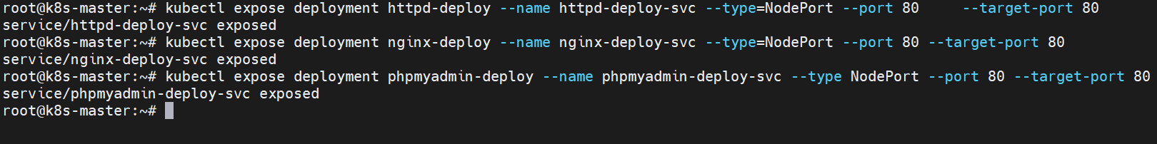

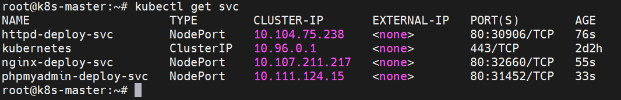

Create namebased Routing:
Vi namebased-ingress.yaml
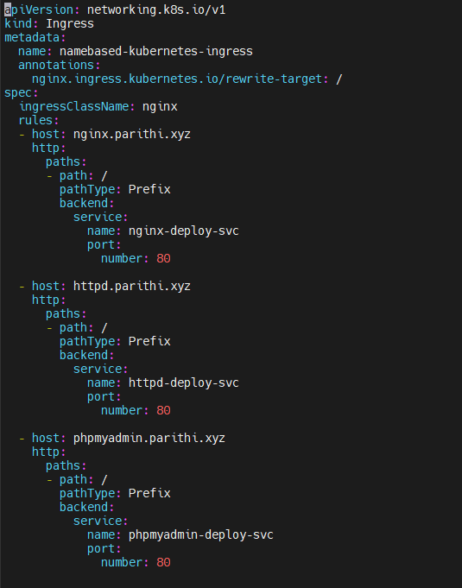

View ingress:

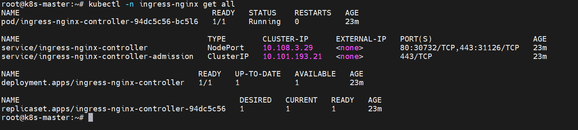

# kubectl -n ingress-nginx edit svc ingress-nginx-controller

type: LoadBalancer
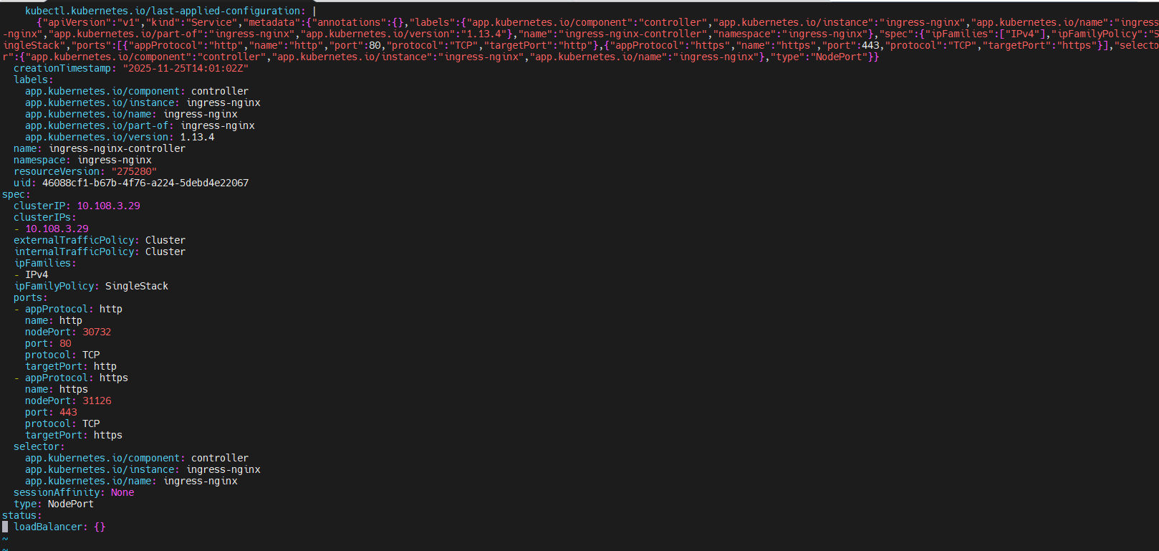

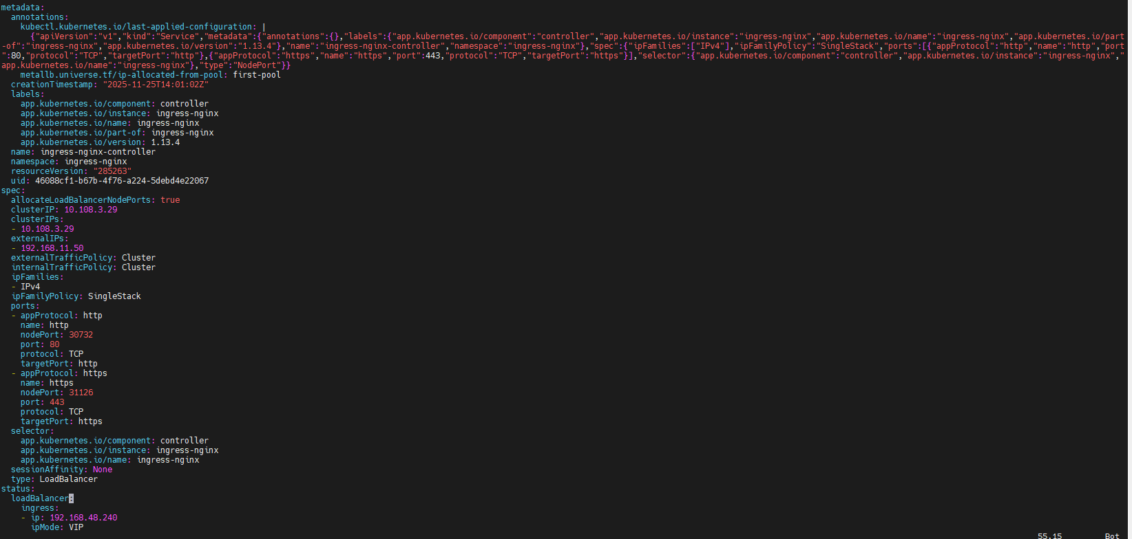

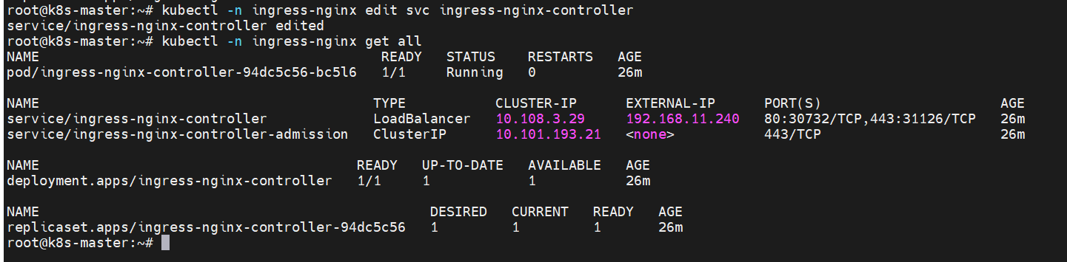

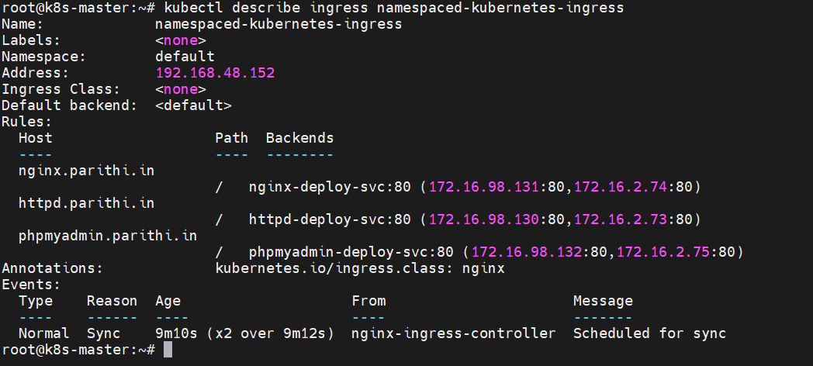

C:\WINDOWS\System32\drivers\etc\hosts

192.168.48.240 nginx.parithi.com
192.168.48.240 httpd.parithi.com
192.168.48.240 phpmyadmin.parithi.com

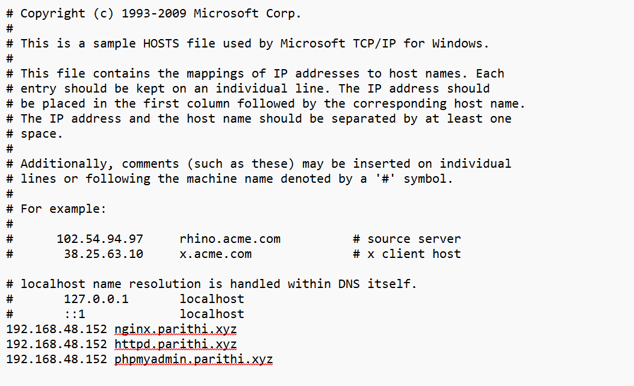

To access application via namebased in browser:
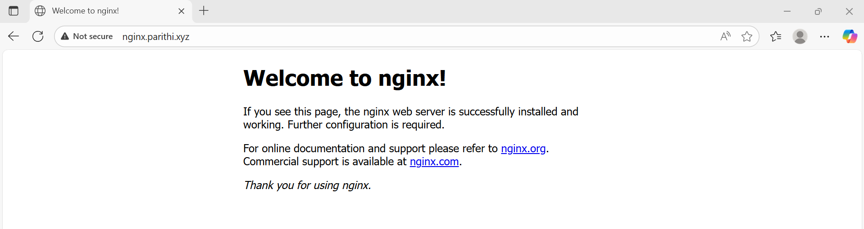

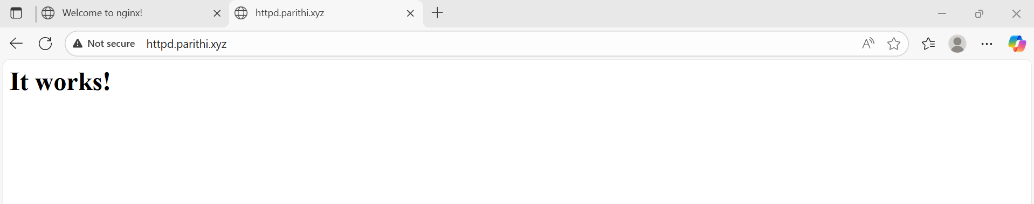

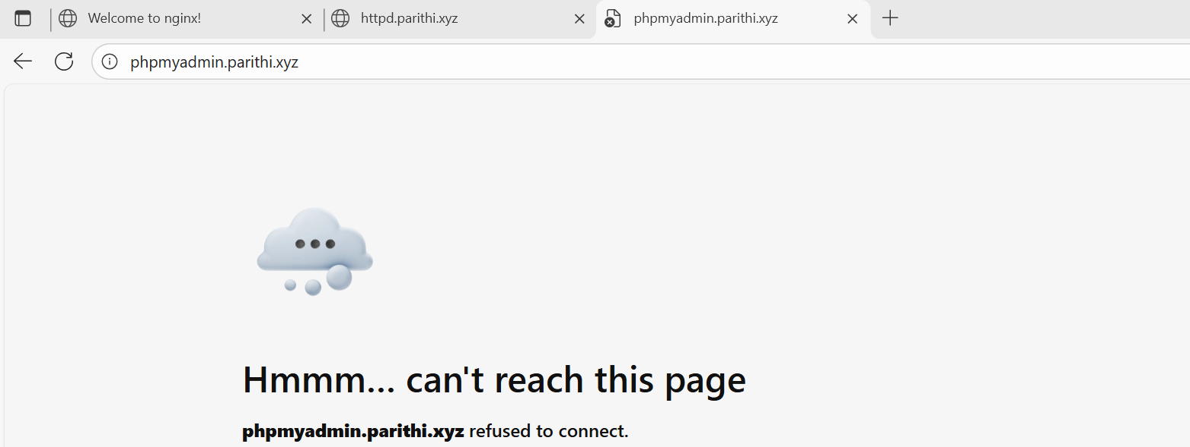
=============================================================

Same as pathbased access.

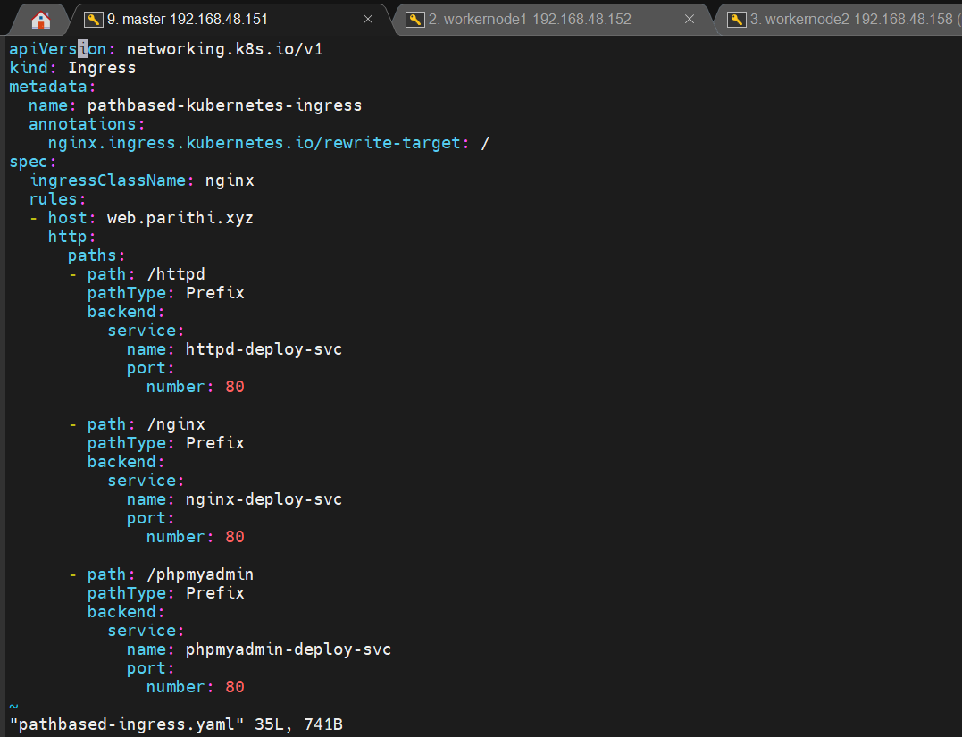

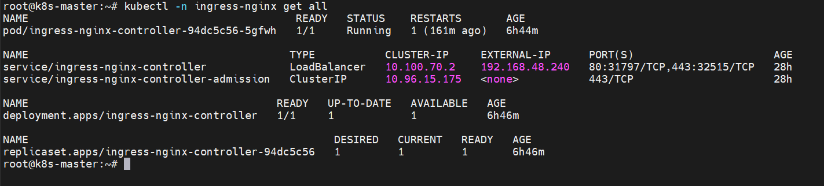

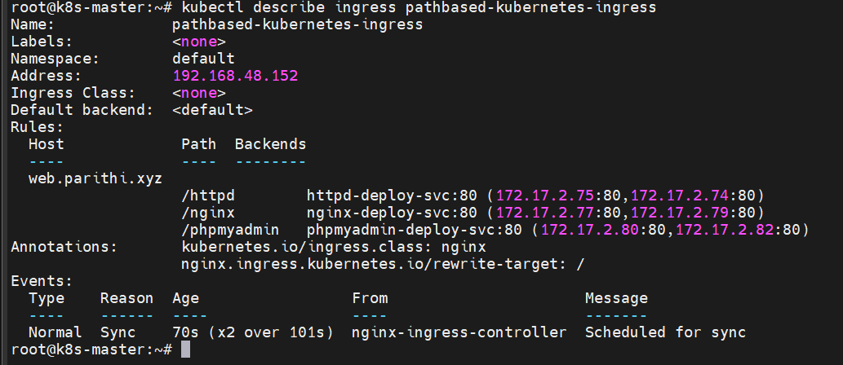

C:\WINDOWS\System32\drivers\etc\hosts

192.168.11.240 web.parithi.xyz
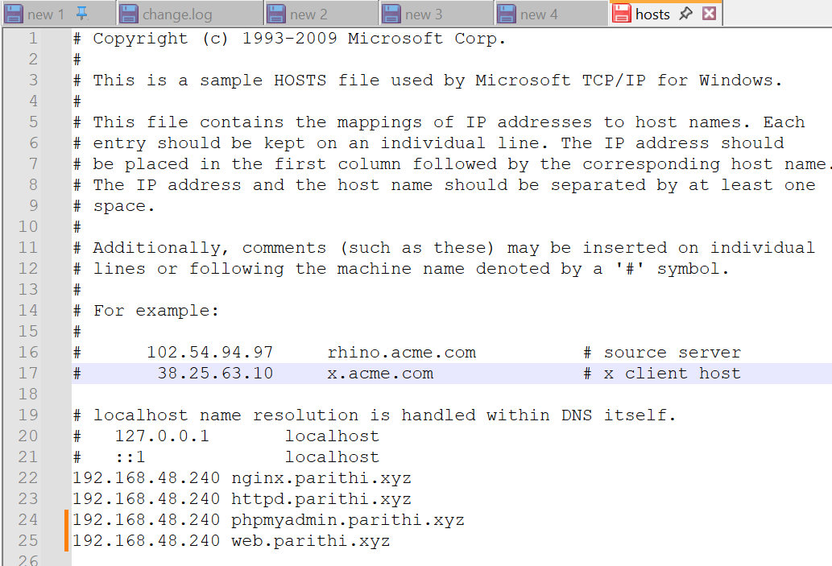

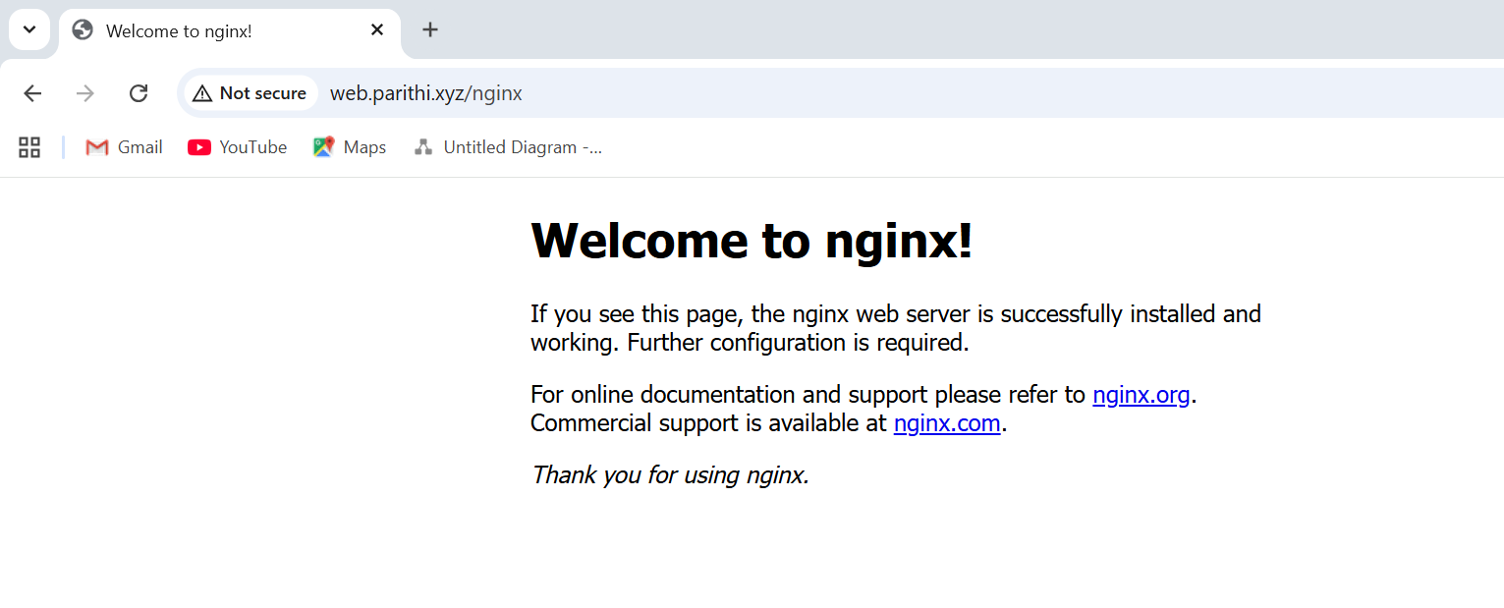



===================================================================================

* Here we want to set ip ranges in mettalLB

